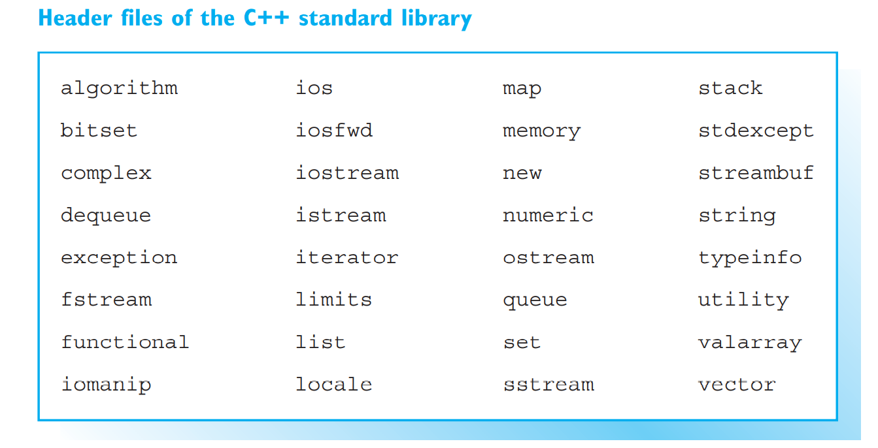

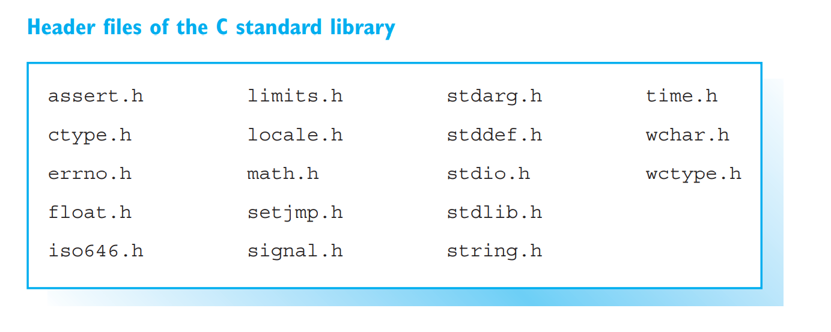

// To use strings.

#include <iostream> // Declaration of cin, cout

#include <string> // Declaration of class string

using namespace std;

int main()

{

// Defines four strings:

string prompt("What is your name: "),

name, // An empty

line( 40, '-'), // string with 40 '-'

total = "Hello "; // is possible!

cout << prompt; // Request for input.

getline( cin, name); // Inputs a name in one line

total = total + name; // Concatenates and

// assigns strings.

cout << line << endl // Outputs line and name

<< total << endl;

cout << " Your name is " // Outputs length

<< name.length() << " characters long!" << endl;

cout << line << endl;

return 0;

}

